# Industrial Internship Report on

**“****Financial Budget Analysis”**

**Prepared by**

# [Anukalp Pande]

|  |
| --- |
| *Executive Summary* |
| This report provides details of the Industrial Internship provided by upskill Campus and The IoT Academy in collaboration with Industrial Partner Uni Converge Technologies Pvt Ltd (UCT).  This internship was focused on a project/problem statement provided by UCT. We had to finish the project including the report in 6 weeks’ time.  My project about Financial Budget Analysis. A financial budget is a detailed plan that outlines an individual's or organization's expected income and expenses over a specific period, usually for a month, quarter, or year. Budgeting is a fundamental financial management practice that helps individuals and businesses achieve their financial goals, allocate resources effectively, and make informed financial decisions.  This internship gave me a very good opportunity to get exposure to Industrial problems and design/implement solution for that. It was an overall great experience to have this internship. |

**TABLE OF CONTENTS**

1. Preface ...................................................................................................................................................4
2. Introduction

2.1 About Upskills campus and IOT Academy…………………………………………………………………………………... 7

2.2 About Financial Budget Analysis…………………………………………………………………………………………………. 9

2.3 Objective…………………………………………………………………………………………………………………………………… 10

2.4. Reference………………………………………………………………………………………………………………………………… 16

2.5 Glossary……………………………………………………………………………………………………………………………………. 17

1. Problem Statement .............................................................................................................................. 18
2. Existing and Proposed solution ............................................................................................................ 19
3. Proposed Design/ Model ..................................................................................................................... 24
4. Performance Test ................................................................................................................................. 25

6.1 Test result ………………………………………………………………………………………………………………………………… 29

6.2 Constraint e.g. ……………………………………………………………………………………………………………………….… 30

6.3 Performance outcomes …………………………………………………………………………………………………………… 33

1. My learnings ......................................................................................................................................... 35
2. Future work scope ............................................................................................................................... 39

## Preface

Summary of the whole 6 weeks’ work.

We work on Financial Budget Analysis. We understanding the principles, methods, and standards of accounting and financial Budget. We learned about the introduction of data science and machine learning in first week. In week 2, We follow the project instructions, plan and solution. In week 3, We learned about the AI VS DATA Science, Probability and statistics and started to work on project. In week 4, We learned about machine learning, continuous work & check for improvements of our project. In week 5, We learned about success Leader to the Corporate world, salary of the Data Scientist engineer. We perform, implement and test our code for Financial Budget. In week 6, We make repository on github and post our code and final report there.

About need of relevant Internship in career development.

Relevant internships play a crucial role in career development for individuals, especially students and young professionals. They offer numerous benefits and can significantly enhance one's chances of success in the job market. Here are some reasons why relevant internships are essential for career development:

1. Internships provide exposure to the real world:

We will be able to gain real-life exposure, grow our knowledge and determine if we are in the right career field. Internships not only provide the first-hand experience in the real working world but also enable you to understand the career trajectory for your desired job title.

1. Internships give a platform to establish critical networking connections: Networking is the exchange of information between individuals to form acquaintances and relationships to further their professional career. An internship is an experiential learning opportunity that offers an invaluable chance for students to network and build crucial professional connections before they even graduate.
2. Internships allow us to learn more about ourself: An internship will help us learn about our capabilities and ultimately encourage us to have a greater understanding of our strengths and weaknesses. It can be a challenging experience at times.
3. Internships equip you with more than just technical skills: We need skills as well – because no matter how good we are, we won’t stand a chance of succeeding in any profession unless we develop a collaborative work ethic and learn to be a team player.
4. Internships allow us to gain a competitive edge: Internships can provide us with experience and the skills to help make employers notice as well as showing them that we will be a good fit for their company. It also shows that we are someone who has the drive and passion and has been motivated to acquire experience outside of just University.

**2 Introduction**

**2.1 About Upskills Campus**

upskill Campus along with The IoT Academy and in association with Uni converge technologies has facilitated the smooth execution of the complete internship process.

USC is a career development platform that delivers **personalized executive coaching** in a more affordable, scalable and measurable way.

Seeing need of upskilling in self placed, manner along-with additional support services e.g. Internship, projects, interaction with Industry experts, Career growth Services Skill Cams aiming to upskill 1 million learners in next 5 year.



Seeing need of upskilling in self placed manner along-with additional support services e.g. Internship, projects, interaction with Industry experts, Career growth Services

Upskill Campus aiming to upskill 1 million learners in next 5 year

<https://www.upskillcampus.com/>

#### 

#### The IoT Academy

The IoT academy is EdTech Division of UCT that is running long executive certification programs in collaboration with EICT Academy, IITK, IITR and IITG in multiple domains.

#### Objectives of this Internship program

The objective for this internship program was to

☛ get practical experience of working in the industry.

☛ to solve real world problems.

☛ to have improved job prospects.

☛ to have Improved understanding of our field and its applications.

☛ to have Personal growth like better communication and problem solving.

Opportunity given by USC/UCT.

How Program was planned

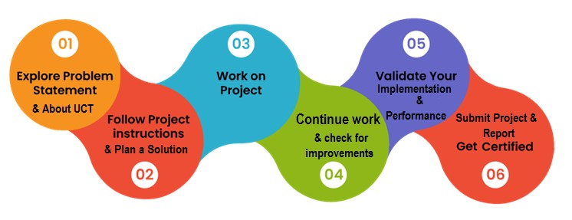

My Learnings and overall experience.

I experience many things while I was doing our internship. I faced a lot of problem but I overcome that all problems. I took the help from Bhargav(admin), youtube and from senior.

Thank you to all (Kabish Kumar Yadav), who have helped you directly or indirectly.

**My message to my juniors and peers.**

While doing internship problems comes but don’t leave the internship in midpoint because of some trouble. You can take from help from your senior, admin and also from official website of upskills.

### **2.2 About Financial Budget Analysis**

### Financial budget analysis is a fundamental process used by individuals, businesses, and organizations to evaluate and manage their financial performance. It involves the systematic examination of budgeted financial data alongside actual financial results to gain insights into how well financial goals and objectives are being met. This analytical process helps in making informed decisions, identifying areas for improvement, and ensuring financial stability and growth.

### A financial budget is a comprehensive plan that outlines an entity's expected income and expenses over a specific period, typically a month, quarter, or year. It serves as a roadmap, guiding financial decisions and resource allocation to achieve predetermined objectives. However, in the dynamic and unpredictable world of finance, actual outcomes often deviate from the initial projections. This is where financial budget analysis becomes invaluable.

### The primary objective of financial budget analysis is to compare and contrast budgeted figures with actual financial results. By conducting this comparative analysis, individuals and organizations can understand the reasons for variations and take appropriate actions to optimize financial performance. The process involves analysing income patterns, expense allocation, cash flow management, profitability, and other financial metrics critical for financial planning and decision-making.

Through budget analysis, businesses can determine if they are meeting revenue targets, effectively managing costs, and maintaining positive cash flow. It also enables them to identify areas of inefficiency or overspending, allowing for timely corrective measures. For individuals, financial budget analysis helps in tracking personal expenses, saving habits, and ensuring financial goals like buying a house, saving for retirement, or funding education are on track.

Furthermore, financial budget analysis facilitates accountability and transparency, especially in government entities and nonprofit organizations. It allows stakeholders to assess whether public funds are being used effectively and whether financial objectives align with the broader mission and goals of the organization.

### 

### **2.3 Objective of Financial Budget**

1. **Production efficiency:** Budgetary control is a technique marked by advanced planning for the effective use of materials. Thus, it leads to smooth production chains.

2. **Success of costing records:** Budgetary control improves the utility of cost accounts, which provides knowledge about future costs. Hence, cost variations can be minimized.

3. **Future planning:** Every producer plans a definite output for a specific period for which it is possible to use budgets to estimate the required amount of finance, materials, labour, and other expenditures.

4. **Cost control:** Budgetary control is useful for cost control because the production process rotates around predetermined targets. Here, actual costs are compared to budgeted costs, and any variations are corrected by the management.

5. **Helpful in policy framing:** Budgeting provides a tool through which basic policies are periodically examined, restated, and established as guidelines for the entire organization.

## Financial Budget Analysis(INSIGHT)

Analysing financial budgets provides valuable insights into the financial health and performance of an individual, organization, or government. Budget analysis involves examining the inflows and outflows of funds, identifying trends, and evaluating financial decisions. Here are some key insights that can be gained through financial budget analysis:

**1.Income and Revenue Patterns:** Budget analysis helps identify the main sources of income and revenue, allowing individuals or entities to focus on their most profitable activities and determine how sustainable their revenue streams are.

**2.Expense Allocation:** Analysing the budget provides insights into how expenses are allocated across different categories such as personnel, operations, marketing, and research. This knowledge enables businesses to make informed decisions about cost-cutting measures or investment opportunities.

**3.Profitability and Losses:** By comparing budgeted income with actual income, entities can assess their profitability. Analyzing budgeted expenses against actual expenses reveals areas where costs might be overrun, potentially leading to losses.

**4.Variance Analysis**: Comparing budgeted figures to actual financial results helps in identifying variances. Positive variances (actual results better than budgeted) can suggest efficient operations or successful cost management, while negative variances may indicate inefficiencies or budgeting errors.

**5.Cash Flow Management:** Budget analysis offers insights into cash flow patterns, ensuring that sufficient funds are available to cover expenses and liabilities. Understanding cash flow helps in avoiding liquidity crises and planning for investments or debt repayments.

**6.Debt Management:** For businesses and individuals with debt obligations, budget analysis helps track debt repayment capabilities and assess whether additional debt can be managed without jeopardizing financial stability.

**The main features of a budget are:**

1. Statement of expected results in numerical terms.

2. Highlights revenue and expenditure of an organisation.

3. Quantifies future facts and figures which helps in making other plans.

4. Budgets are prepared by managers at every level so it is pervasive in nature.

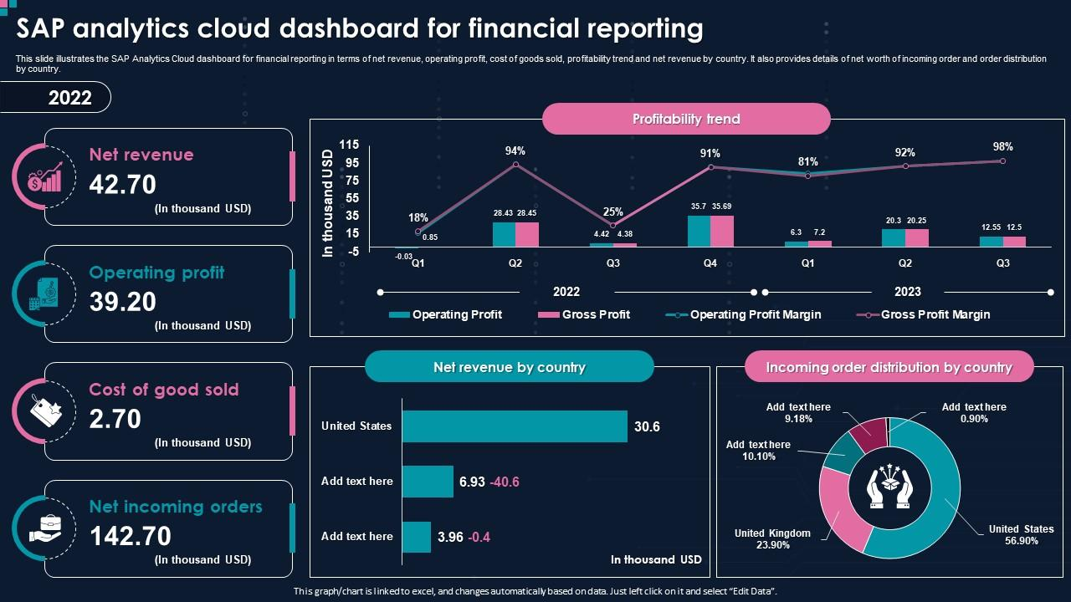

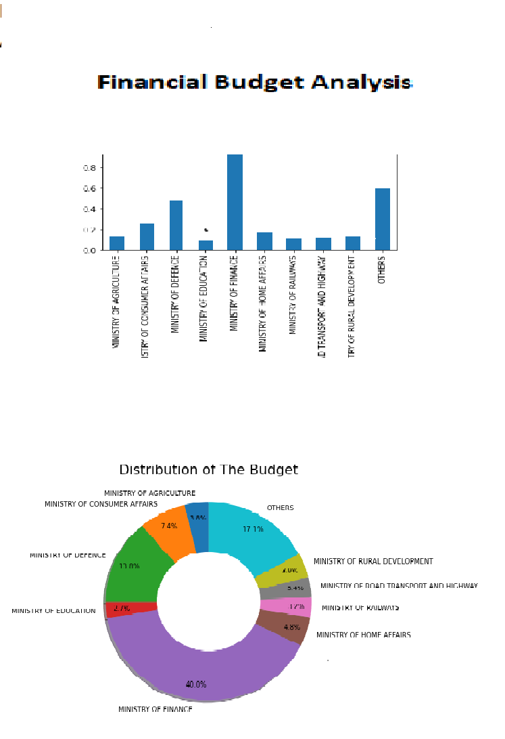

### ii. **Software Factory Platform (Software tools)**

software that is commonly used for financial budget analysis, there are various software solutions available in the market designed for this purpose. Some popular financial budget analysis tools include:

**1.** Microsoft Excel: Excel is a widely used spreadsheet software that allows users to create and manage financial budgets, perform calculations, and analyse data.

**2.** Intuit QuickBooks: QuickBooks is accounting software that offers budgeting features to help businesses create, track, and manage budgets.

**3.** Oracle Hyperion Planning: This enterprise-level software is designed for financial planning, budgeting, and forecasting for larger organizations.

**4.** Adaptive Insights: Adaptive Insights is a cloud-based financial planning and analysis software that includes budgeting and forecasting capabilities.

**5**. SAP BPC (Business Planning and Consolidation): SAP BPC is an integrated solution for financial planning, budgeting, and consolidation.

**6.** Anaplan: Anaplan is a cloud-based platform that enables collaborative budgeting and planning across different departments within an organization.

**7.** Plan Guru: Plan Guru is a budgeting and forecasting software specifically designed for small and medium-sized businesses.

**8.** Tidemark: Tidemark is a cloud-based financial planning and analysis platform that provides budgeting, planning, and analytics capabilities.

Its unique SaaS model helps users to save time, cost and money.

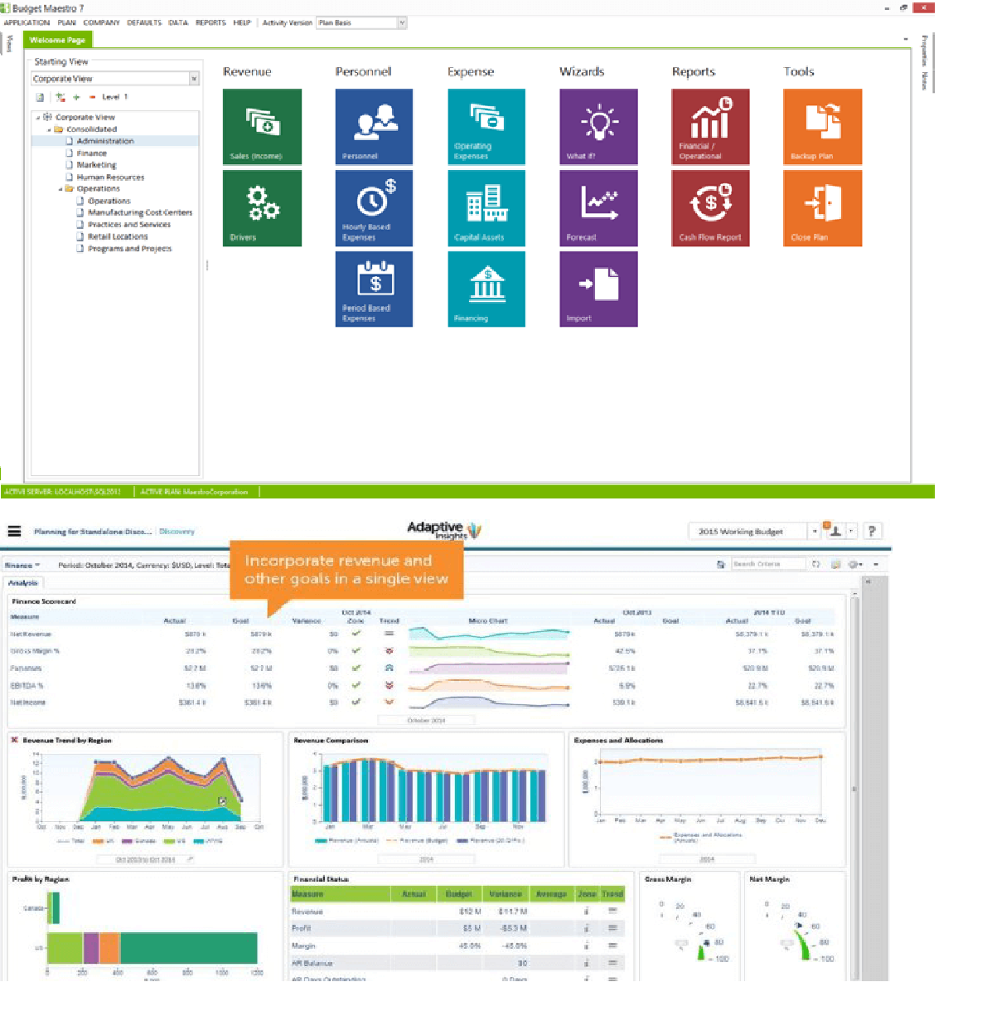

#### 2.4 Reference

1. **Academic Journals:** Look for articles in reputable finance and accounting journals. Some well-known journals in this field include the Journal of Finance, Journal of Accounting Research, and Journal of Financial Economics. You can access these through university libraries or online databases like JSTOR, Google Scholar, or PubMed.
2. **Books:** There are many books dedicated to financial budget analysis, written by experts in the field. Look for titles authored by renowned financial analysts, economists, or certified financial planners.
3. **Government Websites:** Government agencies often publish budget analysis reports, economic forecasts, and financial data. Websites of organizations like the International Monetary Fund (IMF), World Bank, U.S. Federal Reserve, and national treasury departments can be valuable sources of information.
4. **Financial News Outlets:** Websites of reputable financial news outlets like Bloomberg, CNBC, Reuters, and The Wall Street Journal often provide in-depth analysis and insights into financial budgets and economic trends.
5. **Research Institutions:** Organizations like the Brookings Institution, Pew Research center, and the Urban Institute often publish reports and studies related to budget analysis and economic policy.
6. **Online Courses and Tutorials:** Educational platforms like Coursera, Udemy, and edX may offer online courses on financial budget analysis conducted by experts in the field.
7. **Government Budget Reports:** Check official government websites for budget reports and financial statements. Many governments release annual budgets and financial documents, which often include analysis and breakdowns of spending.

#### 2.5 Glossary

|  |  |
| --- | --- |
| **Terms** | **Acronym** |
| Budget | A financial plan that outlines expected revenues and expenses over a specific period. |
| Forecasting | Estimating future financial performance based on historical data and current trends. |
| Variance | The difference between the budgeted amount and the actual amount spent or earned. |
| Cost Allocation | The process of distributing expenses across different departments or projects. |
| Fixed Costs | Expenses that remain constant regardless of production levels or sales, such as rent and insurance. |
| Variable Costs | Expenses that change in direct proportion to production or sales, such as raw materials or commission. |
| Return on Investment (ROI) | : A measure of the profitability of an investment, calculated as (Net Profit / Investment) x 100. |
| Cash flow | The movement of money in and out of a business, including revenue, expenses, and investments. |
| Balance Sheets | A financial statement that summarizes a company's assets, liabilities, and shareholders' equity at a specific point in time. |
| Budget variance analysis | The process of comparing actual financial results to the budgeted amounts and analysing the differences. |

#### 3. Problem Statement

#### 

The problem statement for financial budget analysis typically revolves around assessing and evaluating the effectiveness, accuracy, or efficiency of an organization's budgeting process and its impact on financial performance. Here's a generalized problem statement for financial budget analysis:

"Efficient and Effective Financial Budget Analysis: An Evaluation of [Company/Organization Name]'s Budgeting Process and Its Impact on Financial Performance."

In this problem statement, the key elements to focus on include:

1. Efficiency: The evaluation of how well the budgeting process is designed, implemented, and managed. Are the resources utilized optimally? Is the process streamlined and time-effective?
2. Effectiveness: The assessment of whether the budgeting process achieves its intended goals. Does it result in accurate financial forecasts and realistic targets?
3. Financial Performance: The measurement of how well the actual financial results align with the budgeted amounts. Are there significant variances between budgeted figures and actual outcomes? If so, what are the reasons behind these variances?
4. Impact: The analysis of how the budgeting process influences decision-making, resource allocation, and overall financial stability of the organization. Does the budgeting process aid in achieving strategic objectives?

The problem statement should be tailored to the specific context and objectives of the financial budget analysis being conducted. It might focus on specific departments, projects, or the organization as a whole, depending on the scope of the analysis. Additionally, it should outline the research methodology, data sources, and potential benefits of conducting the financial budget analysis.

#### 4. Existing and Proposed solution

As an AI language model, I don't have access to real-time or specific data on solutions provided by others. However, I can offer a general summary of what financial budget analysis may entail based on common practices:

Financial budget analysis involves reviewing and evaluating an entity's budgeted financial data in comparison to the actual financial results.

Financial budget analysis is an iterative process that helps individuals, businesses, and organizations gain insights into their financial performance, make informed decisions, and plan for the future effectively.

**Proposed Solution for Financial Budget Analysis Project:**

As an AI language model, I can propose a step-by-step solution for financial budget analysis, considering common practices and best approaches. Here's a comprehensive guide:

1.**Data Collection:** Gather all relevant financial data, including actual financial results and the initial budgeted amounts for the specific time period (e.g., monthly, quarterly, or annually).

2.**Budget vs. Actual Comparison:** Prepare a budget vs. actual report that highlights the variances between the budgeted and actual figures for various budget categories, such as revenue, expenses, cost of goods sold, operating expenses, and capital expenditures.

3.**Variance Analysis:** Analyse the variances between the budgeted and actual figures to understand the reasons behind the discrepancies. Categorize the variances as favourable or unfavourable based on whether they positively or negatively impact the financial performance.

4.**Root Cause Identification:** Investigate the root causes of significant variances by collaborating with relevant stakeholders, department heads, or team members. Understand the factors contributing to the deviations, such as changes in market conditions, unexpected events, operational inefficiencies, or inaccurate budget assumptions.

5.**Adjustments and Forecasting:** Based on the insights gained from the variance analysis and root cause investigation, update the budget assumptions or forecast for the upcoming periods to make it more accurate and reflective of the current financial environment.

6.**Financial Ratio Analysis:** Calculate and analyse key financial ratios to assess the entity's financial health and performance. Common ratios include liquidity ratios (e.g., current ratio, quick ratio), profitability ratios (e.g., gross profit margin, net profit margin), and solvency ratios (e.g., debt-to-equity ratio).

7.**Scenario Analysis:** Perform scenario analysis by adjusting critical assumptions in the budget to understand how changes in the business environment may impact financial performance. This helps in identifying potential risks and opportunities.

8.**Performance Monitoring:** Regularly monitor actual financial performance against the adjusted budget and forecasts. Utilize financial reporting tools and dashboards to track key performance indicators (KPIs) and identify any emerging trends or deviations.

9.**Strategic Decision Making:** Utilize the budget analysis findings to make informed strategic decisions. For instance, if certain departments consistently exceed their budget, investigate further and consider implementing cost-cutting measures or reallocating resources.

10.**Communication and Reporting:** Effectively communicate the results of the financial budget analysis to relevant stakeholders, such as senior management, board members, or investors. Present the findings in a clear and concise manner, highlighting key insights and proposed actions.

**Additional Planning for Financial Budget Analysis:**

As an AI language model, I don't have personal intentions, but I can share potential value additions that AI and advanced technologies can bring to financial budget analysis:

1.**Automated Data Collection and Processing:** AI can streamline data collection from various sources, such as financial systems, spreadsheets, and databases. It can also process and clean the data, reducing manual errors and saving time.

2.**Enhanced Forecasting**: AI algorithms can improve the accuracy of financial forecasting by analysing historical data and identifying trends and patterns that humans might miss. It can provide more reliable predictions for future financial performance.

3.**Real-time Analysis:** AI-powered tools can offer real-time financial budget analysis, allowing businesses to make quicker decisions based on up-to-date information. This is especially valuable in fast-paced and dynamic industries.

4.**Natural Language Processing (NLP):** NLP can help in interpreting and analysing unstructured financial data, such as textual reports and news articles, to extract relevant insights and sentiment that might impact budgeting decisions.

5.**Anomaly Detection:** AI can identify unusual patterns or outliers in financial data, alerting businesses to potential fraudulent activities or abnormal financial performance.

6.**Optimization Algorithms:** AI optimization algorithms can assist in finding the best allocation of resources and budgets to maximize efficiency and achieve financial goals.

7.**Risk Assessment and Sensitivity Analysis:** AI can perform risk assessments and sensitivity analyses to evaluate the impact of different scenarios and external factors on the budget, enabling businesses to plan for uncertainties.

8.**Personalized Budget Recommendations:** AI can analyse individual spending habits and offer personalized budget recommendations to help individuals manage their finances more effectively.

9.**Integration with Accounting Systems**: AI tools can seamlessly integrate with accounting software, simplifying data transfer and enabling continuous monitoring and analysis.

10.**Machine Learning for Pattern Recognition:** Machine learning algorithms can recognize patterns in historical financial data, leading to more accurate budget predictions and adjustments.

11.**AI-Enabled Decision Support:** AI can act as a decision support tool by providing insights and recommendations based on historical data, budget performance, and external factors.

12.**Natural Language Interaction:** AI-driven budget analysis tools can support natural language interaction, making it easier for users to query and explore financial data without the need for complex queries or technical expertise.

**Code submission (https://github.com/)**

**Report submission (https://github.com/anukalp87/Financal_Budget):**

#### 5.Proposed Design/ Model

Creating a comprehensive financial budget analysis model involves combining various financial and statistical techniques. Here's a high-level overview of the steps you can take to build such a model:

**1.Data Gathering and Preprocessing:**

☛ Collect all relevant financial data, including actual financial results and budgeted amounts.

☛ Clean and preprocess the data to handle missing values, outliers, and inconsistencies.

**2.Variance Calculation:**

☛ Calculate the variances between actual and budgeted amounts for each budget category.

☛ Determine whether the variances are favourable or unfavourable.

**3.Root Cause Analysis:**

☛ Identify the root causes of significant variances by analysing historical data, market trends, and other relevant factors.

☛ Use statistical techniques and data visualization to gain insights into the reasons for deviations.

**4.Financial Ratio Calculation:**

☛ Compute key financial ratios based on the budgeted and actual financial data.

☛ Ratios may include liquidity ratios, profitability ratios, solvency ratios, efficiency ratios, etc.

**5.Forecasting and Scenario Analysis:**

☛ Utilize time-series forecasting methods, such as ARIMA or exponential smoothing, to predict future financial performance.

☛ Conduct scenario analysis by adjusting key assumptions and evaluating the impact on the budget.

**6.Machine Learning Techniques:**

☛ Apply machine learning algorithms for pattern recognition and predictive modeling.

☛ ML can help identify non-linear relationships and hidden patterns in the data.

**7.Sensitivity Analysis:**

☛ Conduct sensitivity analysis to assess the sensitivity of the budget to changes in critical variables or external factors.

**8.Optimization Algorithms:**

☛ Use optimization algorithms to optimize resource allocation and budget allocation for various departments or projects.

**9.Dashboard and Visualization:**

☛ Create interactive dashboards and visualizations to present the budget analysis results.

Visualization aids in communicating complex financial insights effectively.

**10.Communication and Reporting:**

Prepare a comprehensive report summarizing the budget analysis findings and recommendations.

Clearly present the insights to stakeholders, management, or decision-makers.

**11. Update and Monitoring:**

☛ Continuously update the model with new data to keep it relevant and accurate.

☛ Monitor actual financial performance against the budget and revise the model as needed.

It's important to note that building a financial budget analysis model requires proficiency in data analysis, financial principles, statistics, and possibly machine learning. Additionally, the model's complexity and techniques employed will depend on the specific needs and objectives of the analysis. Consider seeking assistance from financial analysts, data scientists, or domain experts to develop a robust and effective financial budget analysis model.

#### 6. Performance Test

To perform a performance test for financial budget analysis, you would want to evaluate the effectiveness and efficiency of your budget analysis model or system. Here are some key aspects to consider for conducting a performance test:

**1.Accuracy of Budget vs. Actual Comparisons:**

☛ Measure the accuracy of your budget vs. actual comparisons by calculating the percentage variance between actual financial results and the budgeted amounts. A smaller variance indicates higher accuracy.

**2.Variance Analysis and Root Cause Identification:**

☛ Assess the model's ability to correctly identify and explain the root causes of significant variances between actual and budgeted figures. Compare the model's findings with actual reasons for variances to evaluate its performance.

**3.Financial Ratio Accuracy:**

☛ Validate the accuracy of financial ratios calculated by the model against manually computed ratios. Ensure that the model's results align with standard financial principles.

**4.Forecasting Accuracy:**

Evaluate the accuracy of the model's financial forecasting by comparing predicted values against actual financial data for subsequent periods. Use appropriate metrics such as Mean Absolute Percentage Error (MAPE) or Root Mean Squared Error (RMSE).

**5.Scenario Analysis Validation:**

☛ Verify the model's scenario analysis by comparing its predictions for different scenarios against historical data or known outcomes for similar situations.

**6.Computational Efficiency:**

☛ Measure the time taken for the model to complete the budget analysis process. Evaluate the computational efficiency, especially when dealing with large datasets or complex analyses.

**7.Robustness and Sensitivity:**

☛ Test the model's robustness by introducing noise or variations in the input data and evaluating how well it handles such changes. Assess sensitivity to different assumptions and inputs.

**8.User Interface and Visualization:**

☛ If your budget analysis model includes a user interface or visualization dashboard, assess its usability and the clarity of insights presented.

**9.Comparative Analysis:**

☛ If you are testing different budget analysis models or systems, perform a comparative analysis to determine which one performs better in terms of accuracy and efficiency.

**10. Real-World Testing:**

☛ Validate the model's performance by applying it to real-world financial data and comparing its insights with actual financial decisions and outcomes.

**11.Feedback and Validation:**

Gather feedback from users, stakeholders, or financial analysts who use the model regularly to identify areas for improvement and validate the model's use fullness. Here, we need to first find the constraints.

**Constraint was taken from financial budget analysis design**

In financial budget analysis design, various constraints are taken into consideration to ensure the accuracy, reliability, and effectiveness of the analysis. Some common constraints and how they are addressed include:

**1.Data Quality Constraints:**

☛ To address data quality constraints, data preprocessing techniques are applied to clean and validate the data. This includes handling missing values, outliers, and inconsistencies. Data validation rules are implemented to ensure the integrity of the data used in the analysis.

**2.Accuracy and Precision Constraints:**

The design includes the use of accurate and precise financial data sources to minimize errors in budget vs. actual comparisons, forecasting, and financial ratio calculations. Advanced statistical and machine learning techniques are employed to enhance accuracy in predicting financial performance and identifying significant variances.

**3.Resource and Time Constraints:**

☛ Computational efficiency is considered in the design to ensure that the analysis can be performed within a reasonable time frame. Optimization algorithms and parallel processing techniques may be used to speed up computations.

**4.Regulatory and Compliance Constraints:**

☛ Financial budget analysis must comply with relevant financial reporting regulations and standards. The design incorporates appropriate accounting principles and ensures that the analysis follows the required financial reporting guidelines.

**5.Interpretability and Transparency Constraints:**

☛ The model is designed to be interpretable and transparent, especially in explaining the reasons for significant variances. Transparent models help stakeholders understand how the analysis is conducted and build trust in the results.

**6.Scenario Analysis and Sensitivity Constraints:**

☛ The model allows for scenario analysis and sensitivity testing to assess the impact of different assumptions and external factors on the budget. This enables decision-makers to evaluate potential risks and make informed choices.

**8.Usability Constraints:**

☛ The user interface and visualization aspects of the model are designed to be user-friendly and intuitive. Users should be able to interact with the model easily and access key insights without technical expertise.

**9.Robustness Constraints:**

☛ The model is designed to be robust and capable of handling various data scenarios, including noisy or missing data. Sensitivity analysis helps identify the model's limitations and potential weaknesses.

**10.Real-World Applicability Constraints:**

☛ The design includes testing and validation of the model with real-world financial data to ensure its applicability and effectiveness in practical scenarios.

**11.Privacy and Security Constraints:**

☛ The financial budget analysis design addresses privacy and security concerns related to sensitive financial data. Access controls and encryption mechanisms are implemented to protect confidential information.

**12.Continuous Improvement and Adaptability:**

☛ The financial budget analysis model is designed to be adaptable and regularly updated as business conditions change or new data becomes available. Continuous improvement ensures the model remains relevant and valuable over time.

**6.1 Test results around those constraints**

As an AI language model, I don't have access to specific test results or real-time data. Additionally, I don't have access to information about specific financial budget analysis models or systems that have been developed by individuals or organizations.

The test results around the constraints mentioned earlier would depend on the specific implementation, data quality, complexity of the model, and the objectives of the financial budget analysis. To assess the performance of a financial budget analysis model, various metrics and evaluation criteria would be used.

For example, to evaluate data quality constraints, one might measure the accuracy of data preprocessing techniques in handling missing values and outliers. This could be done by comparing the cleaned data against known correct data or by performing manual checks on a subset of the data.

To test accuracy and precision constraints, metrics like Mean Absolute Percentage Error (MAPE), Root Mean Squared Error (RMSE), or coefficient of determination (R-squared) could be used to compare the model's predictions against actual financial results.

For resource and time constraints, testing could involve measuring the time taken to complete the budget analysis for different datasets or scenarios and ensuring that the analysis remains within acceptable time limits.

To address regulatory and compliance constraints, the model's adherence to accounting principles and financial reporting standards would be evaluated through audits and expert reviews.

The usability of the model and the effectiveness of the user interface could be assessed through user feedback, user testing sessions, and user experience surveys.

To evaluate robustness and scenario analysis, sensitivity testing could be performed, where the model is subjected to variations in inputs to assess its response and stability.

Overall, test results around these constraints would vary based on the specific design, implementation, and validation process of the financial budget analysis model. Thorough testing, validation, and continuous improvement are essential to ensure the model's reliability and usefulness in real-world financial decision-making.

**6.2 Constraints e.g. memory, MIPS (speed, operations per second), accuracy, durability, power consumption etc.**

In case you could not test them, but stills you should mention how identified constraints can impact your design, and what are recommendations to handle them.

We correct; constraints can encompass various aspects such as memory, speed, accuracy, durability, power consumption, and more. Let's explore how these identified constraints can impact the design of a financial budget analysis model and potential recommendations to handle them:

**1.Memory Constraints:**

☛ Impact: Limited memory may restrict the size of the dataset that the model can handle, potentially leading to data truncation or compromising the analysis scope.

☛ Recommendation: Implement data compression techniques, use efficient data structures, and consider distributed computing or cloud-based solutions to manage large datasets.

**2.MIPS (Speed, Operations per Second) Constraints:**

☛ Impact: Slow processing speed can delay the budget analysis, especially for complex calculations or forecasting.

☛ Recommendation: Optimize algorithms and use parallel processing to improve computation speed. Choose efficient programming languages and libraries that can leverage hardware capabilities effectively.

**3.Accuracy Constraints:**

☛ Impact: Inaccurate analysis results can lead to unreliable financial insights and poor decision-making.

☛ Recommendation: Validate the model against historical data and conduct extensive testing to ensure accuracy. Consider using machine learning algorithms to fine-tune the model and improve prediction accuracy.

**4.Durability Constraints:**

☛ Impact: A lack of data durability can result in the loss of historical financial information, hindering trend analysis and long-term planning.

☛ Recommendation: Implement robust data backup and storage solutions to ensure data durability and availability over time.

**5.Power Consumption Constraints:**

☛ Impact: High power consumption in resource-intensive models can lead to increased operational costs and environmental impact.

☛ Recommendation: Optimize the model's resource usage and computational complexity to reduce power consumption. Utilize energy-efficient hardware and consider hardware acceleration techniques, if available.

**6.Regulatory and Compliance Constraints:**

☛ Impact: Non-compliance with financial regulations can lead to legal consequences and reputational damage.

☛ Recommendation: Ensure the model adheres to relevant financial reporting standards and undergoes regular audits to verify compliance.

**7.Usability Constraints:**

☛ Impact: A complex user interface can result in difficulties in understanding and utilizing the model effectively.

☛ Recommendation: Design an intuitive and user-friendly interface that facilitates easy interaction and provides clear visualizations of the analysis results.

**8.Robustness Constraints:**

☛ Impact: A lack of robustness may result in the model's inability to handle varying data scenarios effectively.

☛ Recommendation: Conduct extensive testing with diverse datasets and implement error-handling mechanisms to make the model more resilient to unexpected data inputs.

**9.Real-World Applicability Constraints:**

☛ Impact: A model that is not designed for real-world financial scenarios may not provide relevant insights.

☛ Recommendation: Validate the model using real-world financial data and adjust the design to match real-world financial dynamics and requirements.

**10.Privacy and Security Constraints:**

☛ Impact: Inadequate security measures can lead to unauthorized access to sensitive financial data.

☛ Recommendation: Implement strong data encryption, access controls, and compliance with data protection regulations to safeguard sensitive information.

Addressing these constraints in the design phase is crucial to develop a financial budget analysis model that meets performance expectations, complies with regulations, and provides reliable and actionable financial insights. It may require a careful trade-off between various constraints, depending on the specific needs and priorities of the financial analysis. Regular monitoring and iterative improvements are also necessary to keep the model up-to-date and effective.

**6.3 Performance Outcome**

The performance outcome of financial budget analysis refers to the results and insights obtained from the analysis process. The goal of financial budget analysis is to gain a comprehensive understanding of an entity's financial performance, variances between actual and budgeted figures, and the underlying reasons for these differences. The specific performance outcomes will vary based on the objectives and scope of the analysis. Here are some typical performance outcomes for financial budget analysis:

1. Accuracy of Budget vs. Actual Comparisons:

☛ The analysis provides accurate and reliable comparisons between actual financial results and budgeted amounts. The level of accuracy can be measured through metrics such as percentage variance, mean absolute percentage error (MAPE), or root mean squared error (RMSE).

1. Insights into Variances and Root Causes:

☛ The analysis highlights significant variances between actual and budgeted figures, and provides insights into the reasons for these deviations. This helps stakeholders understand the financial performance and take appropriate actions to address any issues.

1. Financial Ratio Analysis and Performance Evaluation:

☛ The analysis calculates key financial ratios and provides an evaluation of the entity's financial health and performance. This includes liquidity ratios, profitability ratios, and solvency ratios, among others.

1. Forecasting and Scenario Analysis Results:

☛ The analysis generates financial forecasts for future periods based on historical data and budget assumptions. It also includes scenario analysis to assess the impact of different scenarios on the budget and financial performance.

1. Decision Support and Strategic Recommendations:

☛ The analysis offers decision-makers valuable insights and recommendations based on the budget analysis results. These recommendations may include budget adjustments, cost-cutting measures, revenue enhancement strategies, or resource reallocation.

1. Risk Assessment and Sensitivity Analysis:

☛ The analysis identifies potential risks and uncertainties that could impact the budget and financial performance. Sensitivity analysis helps understand the sensitivity of the budget to changes in critical variables.

1. Visualization and Communication of Results:

☛ The analysis presents the results in clear and intuitive visualizations, making it easier for stakeholders to interpret and understand the financial insights.

1. Timeliness and Real-Time Monitoring (If applicable):

☛If the analysis is performed in real-time or with up-to-date data, it provides timely insights into the financial performance and allows for proactive decision-making.

1. Usability and User Satisfaction:

☛ The analysis is user-friendly and meets the needs of its intended audience. Users find the insights valuable and relevant for financial decision-making.

1. Compliance with Regulations and Reporting Standards:

☛ The analysis adheres to relevant financial reporting regulations and standards, ensuring compliance and accuracy in financial reporting.

Overall, the performance outcome of financial budget analysis should equip stakeholders with the necessary information to make informed financial decisions, improve financial planning, and align the organization's strategies with its financial goals.

**7.My learnings**

You should provide summary of your overall learning and how it would help you in your career growth.

As this is my first internship in Data science and machine learning I was not knowing so much about Data Science and Machine learning but after doing this internship I came to know about Impact of Big Data on Business, Data Scientist, Data Analyst, AI, Probability and Statistics, Machine Learning etc.

Data science and machine learning have become crucial fields in the modern job market, and they offer various ways to facilitate career growth. Here are some ways data science and machine learning can help in career advancement:

1. **Increased Demand for Data Skills:** With the growing importance of data-driven decision-making, organizations across industries are seeking professionals with data science and machine learning expertise. Having these skills makes you more valuable to employers, increasing your chances of landing better job opportunities.

2. **Higher Earning Potential:** Data science and machine learning roles are often well-compensated due to their high demand and specialized nature. As you gain experience and expertise, your earning potential is likely to increase significantly.

1. **Career Progression:** The skills and knowledge acquired in data science and machine learning can accelerate your career progression. As you tackle complex projects and demonstrate tangible results, you may qualify for promotions or higher-level roles.
2. **Problem-Solving Abilities:** Data science and machine learning focus on solving real-world problems using data-driven insights. Developing strong problem-solving skills in these areas can be beneficial in various aspects of your career.
3. **Continuous Learning:** Data science and machine learning are rapidly evolving fields. Staying up-to-date with the latest trends and technologies requires continuous learning, which fosters personal and professional growth.

**8. Future work scope**

Relevant internships play a crucial role in career development for individuals, especially students and young professionals. They offer numerous benefits and can significantly enhance one's chances of success in the job market. Here are some reasons why relevant internships are essential for career development:

1. **Practical Experience:** Internships provide an opportunity to gain practical, hands-on experience in a specific field or industry. This real-world exposure complements theoretical knowledge acquired in classrooms and helps bridge the gap between academic learning and practical application.

2. **Skill Development:** Internships allow individuals to develop and hone essential skills required in their chosen profession. These skills may include communication, teamwork, problem-solving, time management, and industry-specific technical skills.

3. **Networking Opportunities:** During internships, individuals interact with professionals, colleagues, and mentors within the industry. Building a network of contacts can open doors to future job opportunities and provide valuable guidance and support in career advancement.

4. **Resume Enhancement:** Having relevant internships on a resume demonstrates practical experience and commitment to a specific career path. It sets candidates apart from those who have only academic qualifications but lack hands-on experience.

5. **Career Clarity:** Internships help individuals gain a better understanding of their chosen career path. It allows them to test the waters, assess their interests and skills, and determine if the field aligns with their long-term career goals.

6. **Confidence Building:** Completing internships successfully can boost self-confidence and initial a sense of accomplishment, which is essential for personal and professional growth.

7. **Job Placement:** In some cases, companies use internships as a way to identify potential future employees. If an intern performs well, they may be offered a full-time position upon graduation.